Homework 3

1)(20 points) related terms: (procedures, exception,implicit cursor)

write a procedure that accept one parameter (vendor ID) and the procedure print the phone number and the address of the vendor (address1, city, zip code, state). The procedure should check whether the vendor have a phone number registered or not, if not, the procedure should print a message saying "No phone is registered to this vendor". The procedure must handle exception "no_data_found". The exception must produce the message "No Data Found, invalid inputs".

Try three test cases and submit their message screenshots:

“create or replace procedure Find_Phone_Num(v_id vendors.vendor_id%type)

as

v_phone VENDORS.VENDOR_PHONE%type;

v_address1 vendors.vendor_address1%type;

v_city vendors.vendor_city%type;

v_zip VENDORS.VENDOR_ZIP_CODE%type;

v_state vendors.vendor_state%type;

begin

select vendor_phone, vendor_address1, vendor_city, vendor_zip_code, vendor_state

into v_phone, v_address1, v_city, v_zip, v_state

from vendors where vendor_id = v_id;

if v_phone != NULL then

dbms_output.put_line('Phone Number: ' || v_phone ||', Address: '|| v_address1 || v_city || v_zip || v_state);

else

dbms_output.put_line('No phone is registered to this vendor');

end if;

exception when no_data_found then

dbms_output.put_line('No Data Found, invalid inputs');

end;”

1. Vendor Id: 12

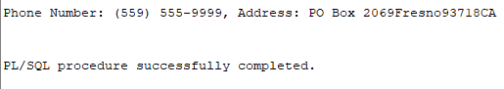

1. Vendor_id: 120

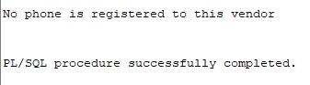

1. Vendor_id: 134

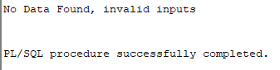

2) (30 points) related topics(functions, procedure, count(*), implicit cursor)

write a function that accept one paramenter (invoice_id) and return the number of items for that invoice. (FYI: for each invoice we can find the number of items from the table invoice_line_items. e.g invoice id=19 has two items). create a procedure that will accept one parameter ( invoice_id) and the procedure will call the function and print the message " The number of items for invoice_id : $ is % items" where $ is going to be replaced with the input invoice_id and % is going to be replaced with the result returned from the function.

Function:

“create or replace function Invoice_Count(i_id in invoices.invoice_id%type)

return number is

return_count number;

begin

select line_item_amt into return_count from invoice_line_items

where invoice_id = i_id;

return return_count;

exception when no_data_found then

dbms_output.put_line('No Data Found, invalid inputs');

end;”

Procedure:

“create or replace procedure Print_Invoice_Count(i_id invoices.invoice_id%type)

as

begin

dbms_output.put_line('The number of items for invoice_id : ' || i_id || ' is ' || Invoice_Count(i_id) || ' items.');

exception when no_data_found then

dbms_output.put_line('No Data Found, invalid inputs');

end;”

Try three test cases and submit their message screenshots:

1. Invoice_id: 7

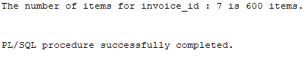

1. Invoice_id:19

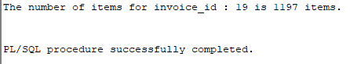

1. Invoice_id: 100

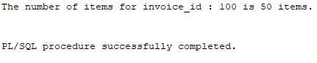

3) (20 points) related topics (create table, insert statements, row level trigger, trigger before timing, trigger insert event, new., commit)

create a table called "website_names" that has three columns:

* Website_id: number
* Website_name: varchar(40)
* Website_create_date:date

Populate your table with the following data:

1. (1,umbc,10-22-1999)
2. (2,morgan,12-16-2006)
3. (3,towson,06-04-2009)

“insert into website_names(website_id, website_name, website_create_date) values (1, 'umbc', TO_DATE('10-22-1999','mm-dd-yyyy'));

insert into website_names(website_id, website_name, website_create_date) values (2, 'morgan', TO_DATE('12-16-2006','mm-dd-yyyy'));

insert into website_names(website_id, website_name, website_create_date) values (3, 'towson', to_date('06-04-2009','mm-dd-yyyy'));”

Create a row level trigger that fires before the insert operation associated with website_names table. The trigger displays the new attribute values for website_name and website_create_date

Try two test cases:

1. Insert into website_names values(5,'johnsHopkinsUniversity', to_date('10-22-2000','mm-dd-yyyy')

“set serveroutput on;

Insert into website_names(website_id, website_name, website_create_date) values (5,'johnsHopkinsUniversity', to_date('10-22-2000','mm-dd-yyyy'));

select website_name, website_create_date from website_names;”

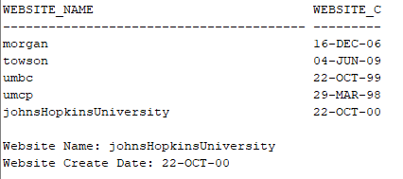

1. Insert into website_names values(5,'umcp', to_date('03-29-1998','mm-dd-yyyy')

“set serveroutput on;

Insert into website_names(website_id, website_name, website_create_date) values (5,'umcp', to_date('03-29-1998','mm-dd-yyyy'));

select website_name, website_create_date from website_names;”

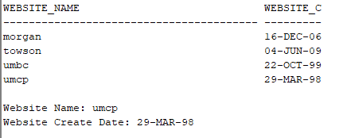

submit the code and screenshot of the messages results.

“SET SERVEROUTPUT ON;

CREATE OR REPLACE TRIGGER insert_website BEFORE

insert on website_names

FOR EACH ROW

BEGIN

dbms_output.put_line('Website Name: ' || :new.website_name);

dbms_output.put_line('Website Create Date: ' || :new.website_create_date);

exception when no_data_found then

dbms_output.put_line('No Data Found, invalid inputs');

END;”

4)(30 points) related topics (insert statements, row level trigger, trigger before timing, trigger insert event, exceptions, explicit cursor,for loop, “LIKE” operation, “%” from week3 slides, commit )

Create a row level trigger that fires before the insert operation associated with website_names table. the trigger should check if the value of website_name has any similarity with the names of the websites in the table, if yes, it will print a message that "the name of the website has similarity with one of the websites in the table" and then the trigger will raise RAISE_APPLICATION_ERROR(-20001, 'similarity in names');

Try two test cases and take a screenshot of result messages:

1. “Insert into website_names values (5,’umbcc’, to_date('10-05-2010','mm-dd-yyyy'));

Select * from website_names;”

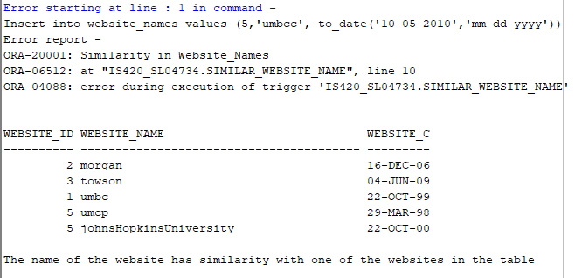

1. “Insert into website_names values 5,’morganStanley’, to_date('10-05-2012','mm-dd-yyyy'));

Select * from website_names;”

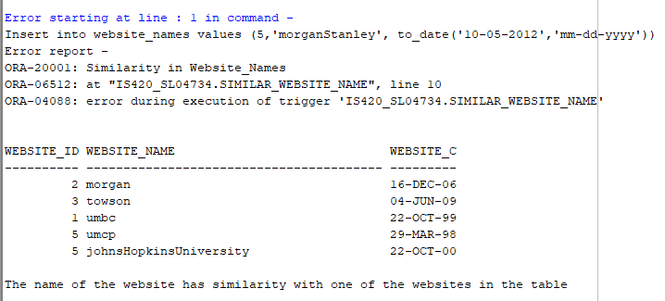

Hints:

* you will need a cursor to hold all names in website_names table
* You will check similarity using 'LIKE' statement and '%websiteName%'
* You will raise application exception to abort insertion upon the similarity using this command line : RAISE_APPLICATION_ERROR(-20001, 'similarity in names');
* You will need to add commit to the insert statement to fire the trigger. For example
  + Insert into website_names values(5,'john hopkins university', to_date('10-22-2000','mm-dd-yyyy');

commit;

“SET SERVEROUTPUT ON;

CREATE OR REPLACE TRIGGER similar_website_name BEFORE

insert on website_names

FOR EACH ROW

declare

cursor similar_cursor is

select website_name from website_names;

similar_row similar_cursor%rowtype;

BEGIN

for similar_row in similar_cursor loop

if :new.website_name like '%' ||similar_row.website_name || '%'

then

dbms_output.put_line('The name of the website has similarity with one of the websites in the table');

Raise_application_error(-20001, 'Similarity in Website_Names');

end if;

End loop;

END;”